**IT Number - IT24101717**

**Name – Perera M.A.D.S**

01)



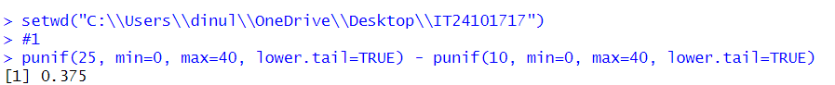

02)

03)

i), ii)

